Samarth Rural Educational Institute’s
Samarth College of Computer Science, Belhe
Academic Year 2026-2027(SEM-V)
T.Y.B.Sc.(Information Technology)
Practical NO:10

Title : 10. Form Data Handling, Validation and Database Integration
Roll NO: 70 Batch : C

SET A :
Q1. Student Registration Form
Create a Flask application connected to database. Requirements:
- Create an HTML form to accept:
  - Student ID
  - Student Nam
  - Course
- Validate that no field is left blank.
- Store the data in the database.
- Display a success message after submission.
Ans:
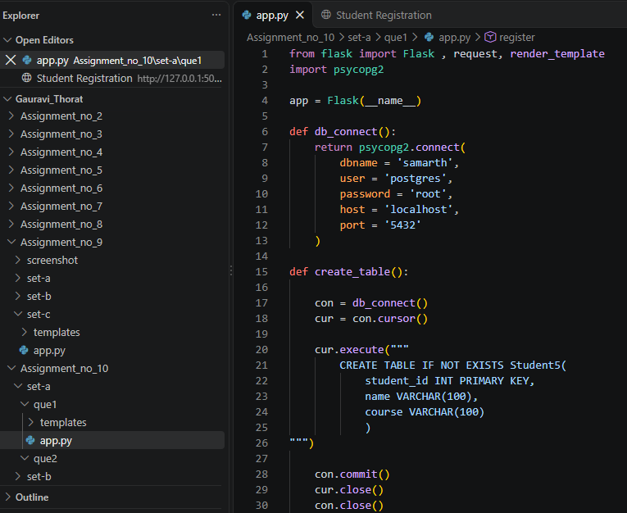
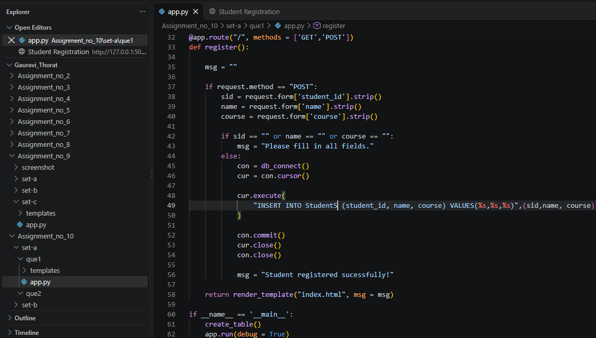
Index.html
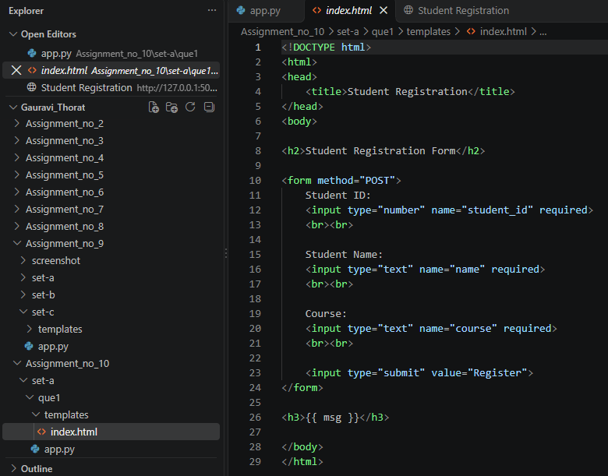
Output:
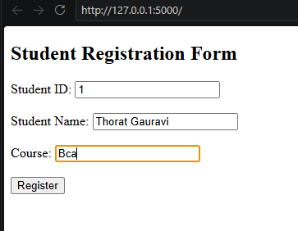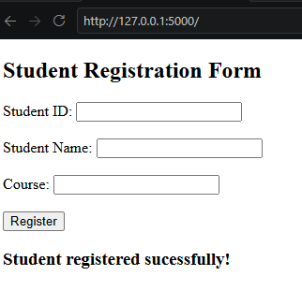

Q2. Employee Information Form
Create a Flask application connected to database. Requirements:
- Accept:
  - Employee ID
  - Employee
  - Name
o Department
- Validate that all fields are compulsory.
- Store data in the database.
- Display entered information after successful submission.

Ans:
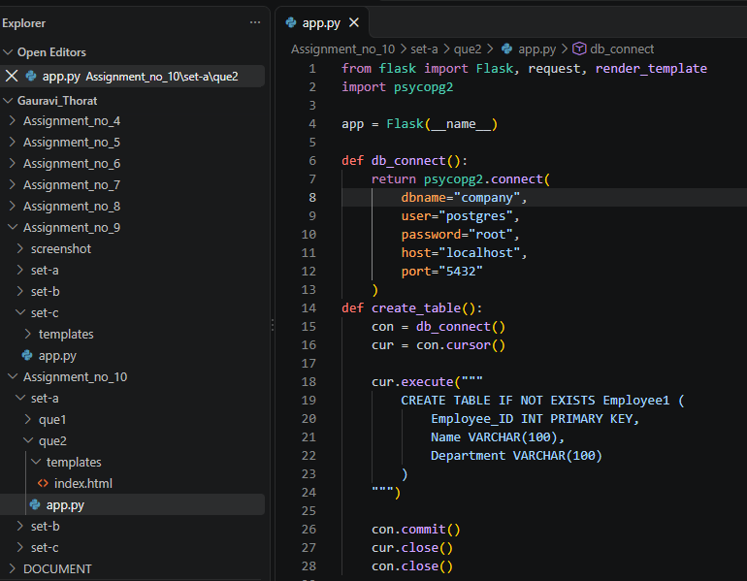
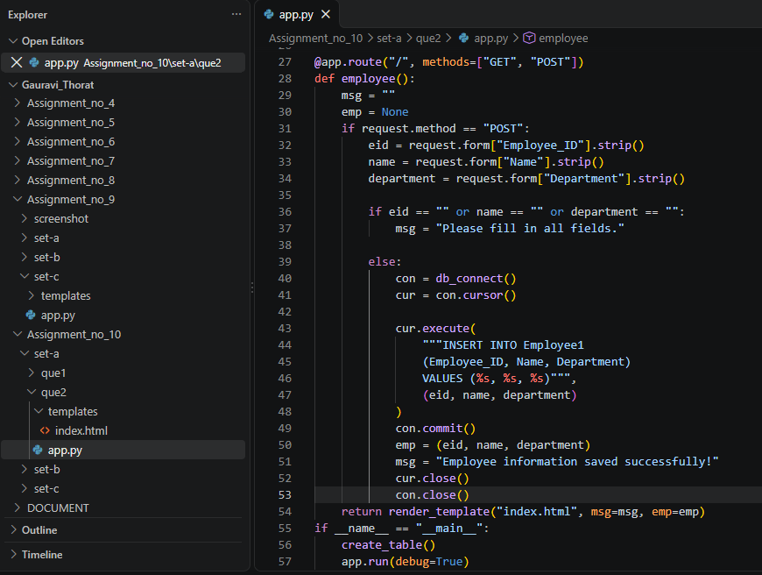
Index.html
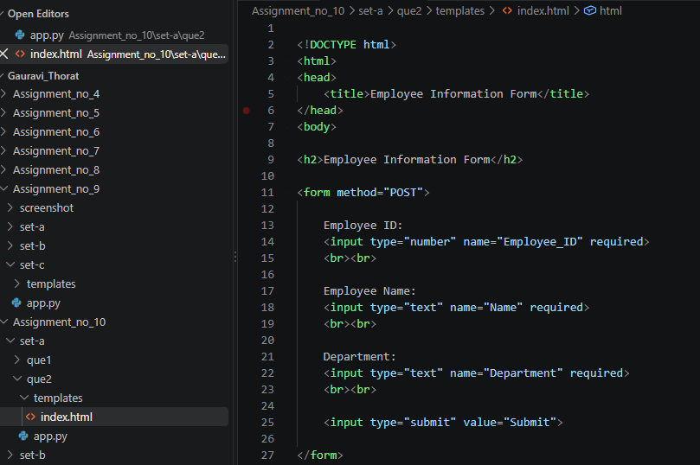
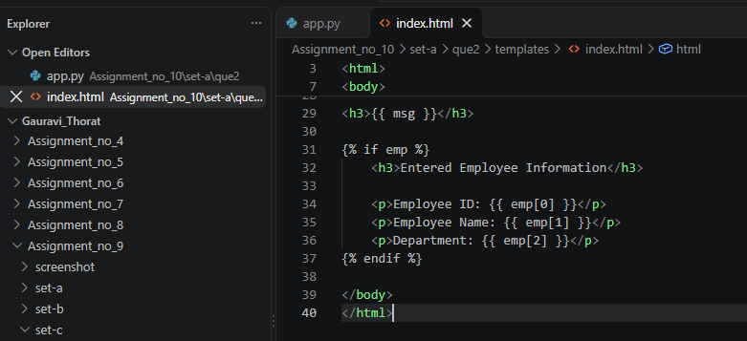
Output:
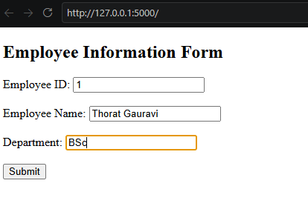
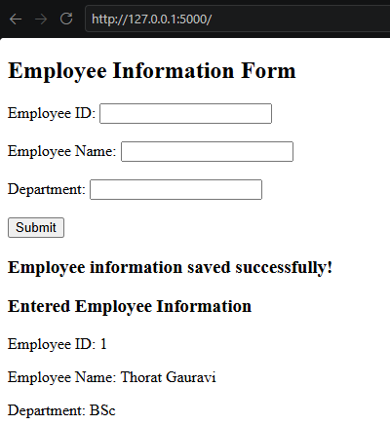
SET B:
Q1. Student Feedback Form
Create a Flask application connected to database. Requirements:
- Accept:
  - Student Name
  - Subject
  - Feedback
- Validate that feedback cannot be empty.
- Store the feedback in the database.
- Display all submitted feedback records.
Ans:
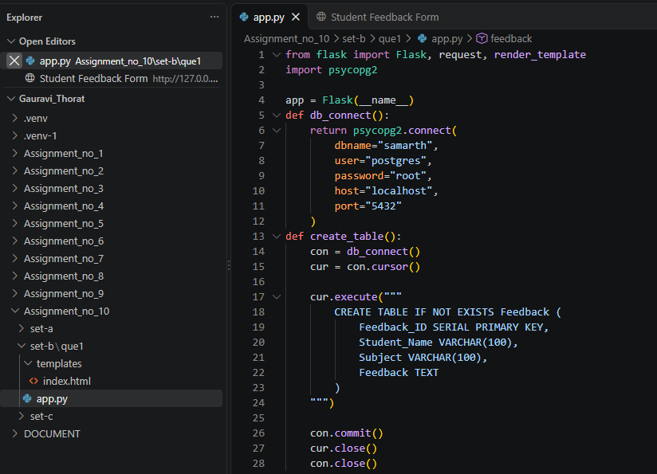
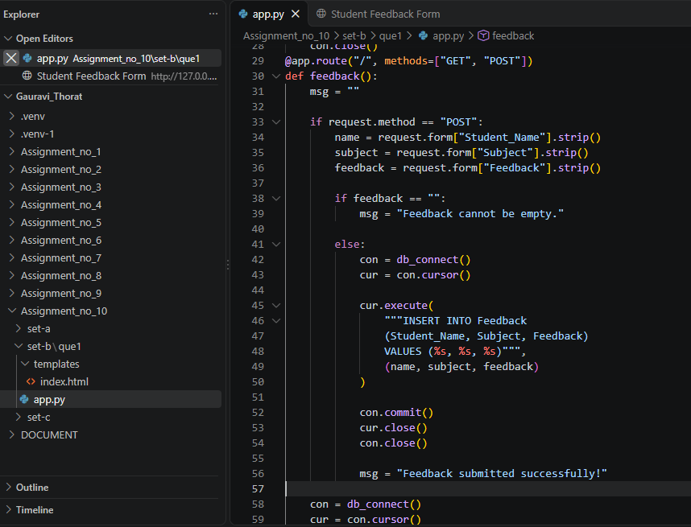
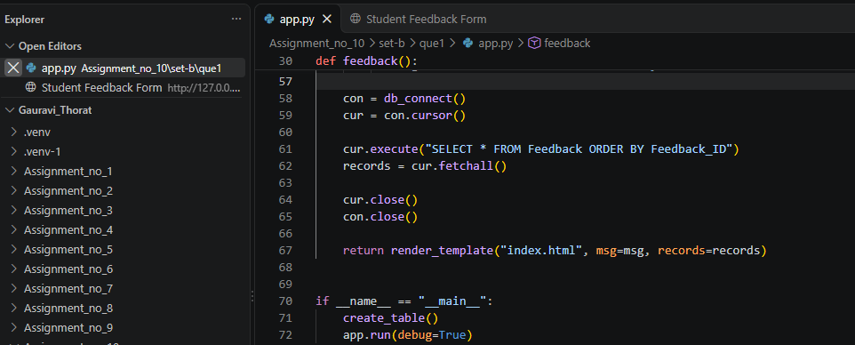
Index.html
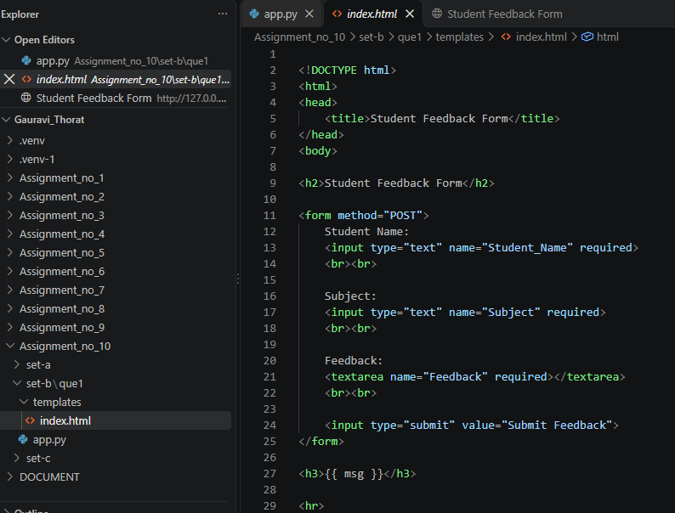
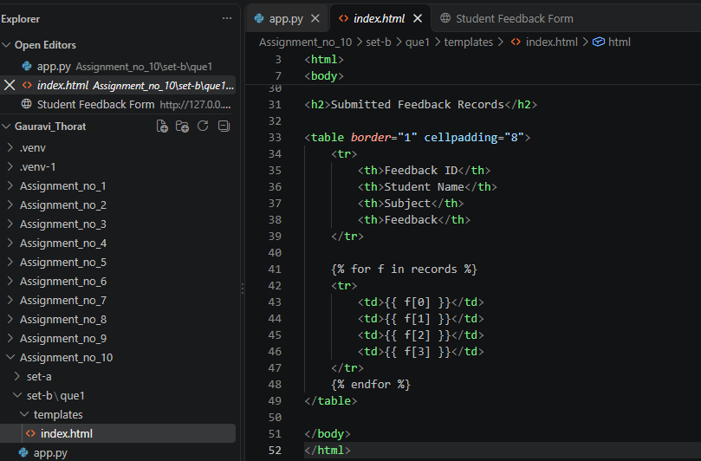
Output:
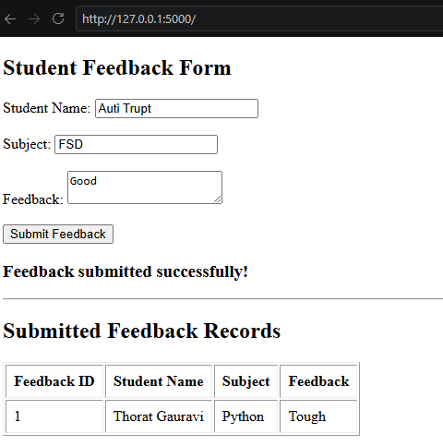

SET C :
Q1. Course Registration Form
Create a Flask application connected to database. Requirements:
- Accept:
  - Student Name
  - Email
Course Name Validate:
  - No field should be blank.
  - Email must contain '@'.
- Store data in database.
- Display all registered students.
Ans:
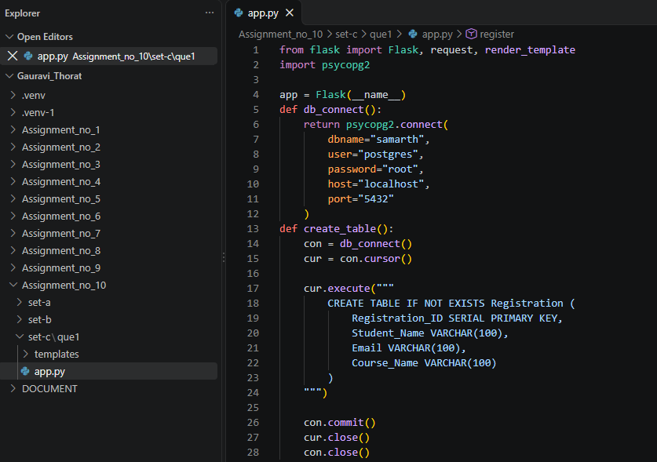
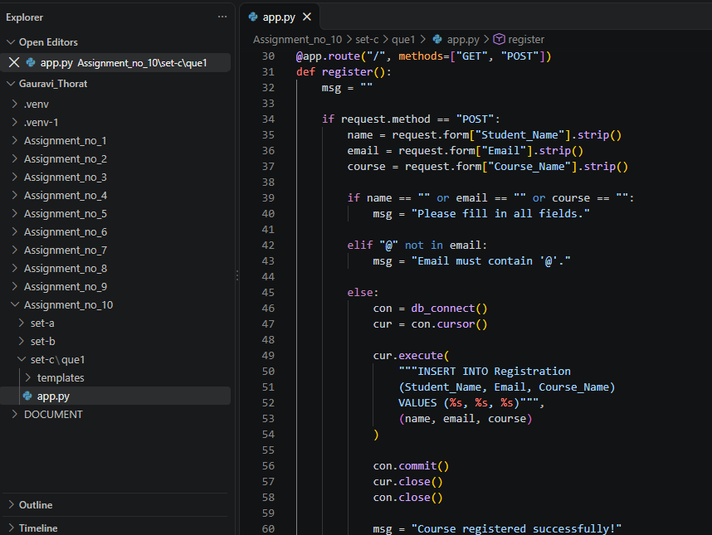
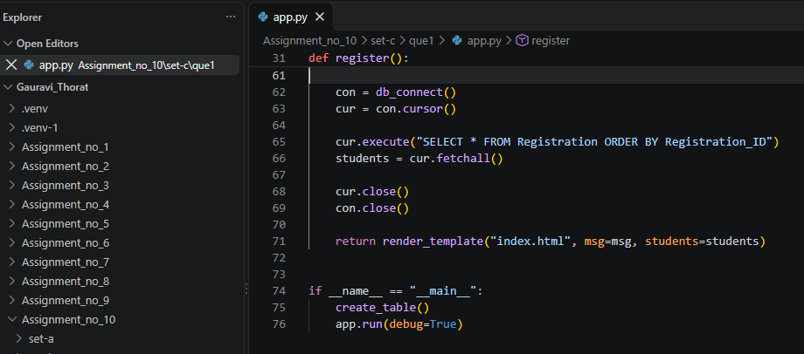
Index.html
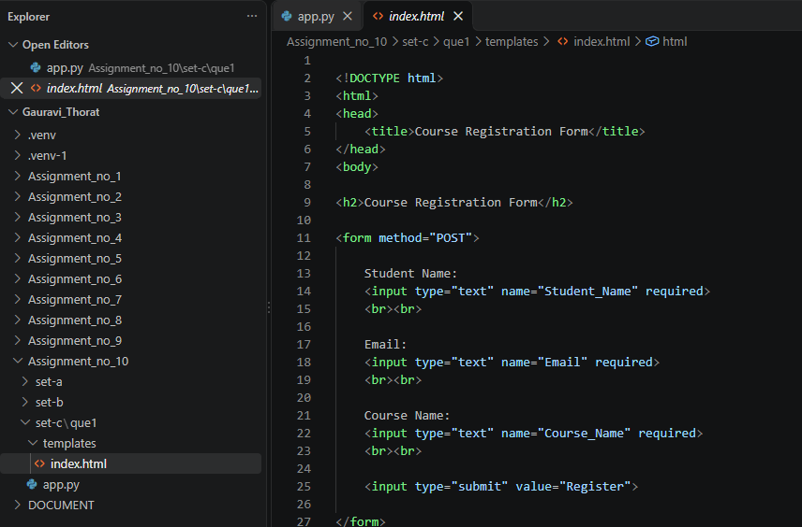
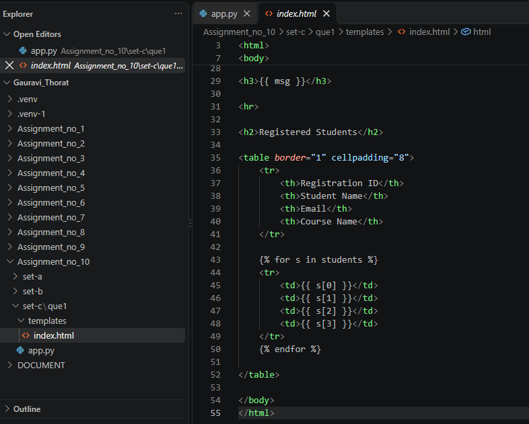
Output:
